**JUNGLE CALL**

Aims:

1) Summarize of the material on "favorite fairy tales", "Animals", training of lexical and grammatical skills;

2) Develope of memory, attention, thinking, monological speech, phonemic hearing;;

3) upbringing of love for the language being studied.

Equipment: pictures of animals, big pictures of pigs, cards or envelopes with tasks, crosswords, scarf.

**Planned activities:**

**I.Organization moment**.

- Good afternoon, children! Today we have a special lesson. It is a game – lesson «**JUNGLE CALL».**

- Today you will ask questions, solve riddles and play games!

- I want you to divide into two groups. The first group is “The Beasts of Prey” and the second - “The Beasts of Grass”.

Well, teams, you have some time to choose the captain and decide how to present your team.

**II. Realization of competition.**

Competition 1 Greeting.

* Tell us about yourself, please. (Команды рассказывают о себе и представляют капитанов.) For best greeting each team will get 1 point.

Competition 2 “**Riddles”.**

Look at these pictures. You can see many animals. Solve riddles:

1. It is a small animal. It likes fish. (a cat)
2. It is orange. It is not big. It can run. It is very cunning. (a fox)
3. This animal lives at home or in the street. It is a man’s friend. (a dog)
4. It is green. It can swim and run. It can’t climb and jump. (a crocodile)
5. It big and strong. It’s grey. It likes to help his friends. It lives in Africa.(an elephant)
6. It’s clever. It can jump and climb. It lives in a tree. It’s very funny. (a monkey)
7. I live on a farm. I am pink. I have a little tail. My nose is called a snout. And I say “Oink, oink”.  
   I am …. (PIG);
8. I have 4 legs and a tail. I am very smart. I like to play with you. When I see a cat, I say “Woof, woof” I am ….(DOG);
9. I am a pet. I am soft and furry. I like to sleep and drink milk. I don’t like mice and dogs. I say “Meow, meow”. I am ….(CAT);
10. I am a big farm animal. I can be black, white or brown. I like to eat green grass. I give milk. I can say “Moo, moo”. I am …. (COW);
11. I am small and shy. I have eight legs. I eat bugs. I catch them in my web. I am a… (SPIDER);
12. Green and long , With many teeth. Beautiful smile - It’s …(A CROCODILE.)
13. A very long nose. It grows and grows. Не is huge and likes fun. It is … (AN elephant)

For each solved riddle team get 1 point.

**Competition 3**

“**Puzzle”**

Teams receive envelopes with pictures. It is necessary to collect the puzzle and say what there is an image.

1. The Beasts of Prey 2. The Beasts of Grass

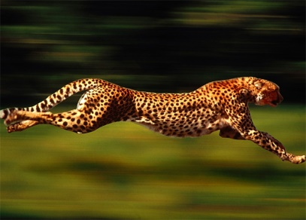 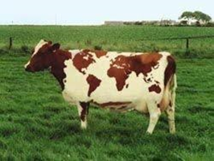  
For each word – 1 point.

**Competition 4**

**Crossword**

|  |  |  |  |  |  |  |  |  |  |
| --- | --- | --- | --- | --- | --- | --- | --- | --- | --- |
| **e** | **s** | **g** | **s** | **a** | **a** | **s** | **c** | **a** | **t** |
| **r** | **m** | **i** | **a** | **p** | **i** | **g** | **s** | **s** | **r** |
| **h** | **o** | **r** | **s** | **e** | **d** | **e** | **s** | **c** | **d** |
| **u** | **u** | **a** | **a** | **d** | **g** | **l** | **i** | **o** | **n** |
| **o** | **s** | **f** | **t** | **i** | **g** | **e** | **r** | **c** | **d** |
| **o** | **e** | **f** | **r** | **o** | **g** | **p** | **y** | **k** | **s** |
| **y** | **h** | **e** | **n** | **o** | **o** | **h** | **r** | **u** | **r** |
| **w** | **f** | **i** | **s** | **h** | **g** | **a** | **y** | **i** | **z** |
| **d** | **o** | **g** | **q** | **m** | **o** | **n** | **k** | **e** | **y** |
| **c** | **f** | **e** | **e** | **u** | **y** | **t** | **h** | **m** | **n** |
| **c** | **c** | **r** | **o** | **c** | **o** | **d** | **i** | **l** | **e** |

**-**You must find 15 animals.

For one animal you get -1 point

**Competition 5 «Poor Piglet»**

On the Board we have two large drawings of a pig.

- Guys, look what a sad penny today!!! While he was coming to visit you he lost his nose! Help him and draw his nose on place.

Children blindfolded, draw the nose of the Piglet. The most nimble and accurate will get a score!

**III. Conclusion of the lesson, Team awards.**

We count the number of points, determine the winners, who took first place and who is second.